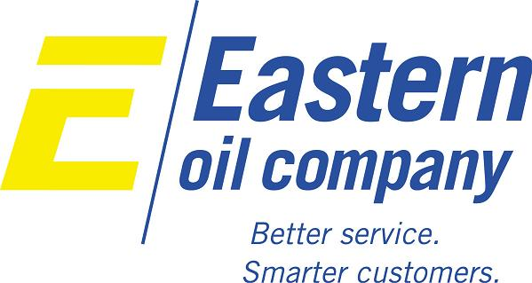
General Motors Specifications/Approvals
Below is a list of General Motors Specifications and OEM Approvals that Eastern Oil can supply. Please contact us if you have any questions or inquiries we can help you with!
9981325A | 9985007
9981386 | 9985038
9981421 | 9985164
9981720 | 9985254
9981936 | 9985714
9986104

