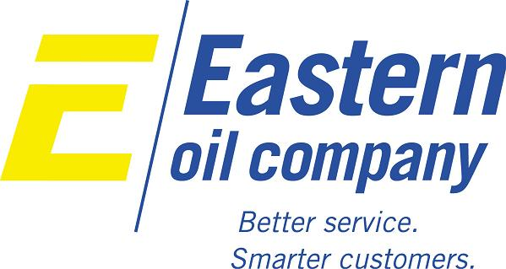
Chrysler Specifications/Approvals
Below is a list of Chrysler Specifications and OEM Approvals that Eastern Oil can supply. Please contact us if you have any questions or inquiries we can help you with!
DBL 6827.42 |  | MS5451
MS2342 |  | MS5646
MS3340 |  | MS7314
MS3701 |  | MS8677
MS4178 |  | MS9602
MS4517 |  | MS9990

